

**HOSPITAL MANAGEMENT SYSTEM**

**Course Code:CSE134**

**Course Title:Data Structure Lab**

**Submitted TO :**

**Rishad Amin Pulok**

Lecturer

Department of Computer Science & Engineering

Metropolitan University, Bangladesh

**Submitted By:**

**Prity Saha Chnoya**

ID No: 232-115-321

**Farhana Nowshin**

ID No: 232-115-322

**Adrita Chakraborty**

ID No: 232-115-324

Batch:59

Section:I

**Date of Submission:** 12/11/2024

Introduction:

The project Hospital Management system includes registration of patients, storing their details into the system, and also computerized billing in the pharmacy. The software has the facility to give a unique id for every patient and stores the details of every patient and the staff automatically. It includes a search facility to know the current status of each room. User can search availability of a doctor and the details of a patient using the id. The Hospital Management System can be entered using a username and password. Only they can add data into the database. The data can be retrieved easily. The interface is very user-friendly. The data are well protected for personal use and makes the data processing very fast. Hospital Management System is powerful, flexible, and easy to use and is designed and developed to deliver real conceivable benefits to hospitals. Hospital Management System is designed for multispecialty hospitals, to cover a wide range of hospital administration and management processes. It is an integrated end-to-end Hospital Management System that provides relevant information across the hospital to support effective decision making for patient care, hospital administration and critical financial accounting, in a seamless flow. Hospital Management System is a software product suite designed to improve the quality and management of hospital management in the areas of clinical process analysis and activity-based costing. Hospital Management System enables you to develop your organization and improve its effectiveness and quality of work. Managing the key processes efficiently is critical to the success of the hospital helps you manage your processes.

Background Study:

In today's fast-paced healthcare environment, efficient management of hospital operations is crucial. Manual record-keeping and traditional administrative methods can be time-consuming, error-prone, and hinder the delivery of quality patient care. A Hospital Management System (HMS) is a computer-based solution designed to automate and streamline various hospital processes. By digitizing patient records, appointment scheduling, billing, emergency services, and staff management, HMS helps hospitals improve efficiency, reduce costs, and enhance patient satisfaction. In traditional setups, such information was managed manually, leading to inefficiency and a higher likelihood of errors.

In this project, various C programming techniques are used:

(i)Structures: Used to group patient, doctor, and staff details in single entities.

(ii)Functions: Modular approach for each feature, such as patientManagementMenu,doctorManagementMenu,appointmentManagementMenu,emergencyServicesMenu,billingManagementMenu and staffManagementMenu.

(iii)Control Statements and Loops: Used to navigate through the main menu and interact with different options.

(iv)File Handling (if implemented): Stores and retrieves information even after the program is closed.

We drew inspiration from numerous research papers to develop our project. These papers guided us on effective use of functions, files, and structures, enabling us to create a unique and innovative solution.[1][2][3]

Features:

1. User Authentication and Access Control: 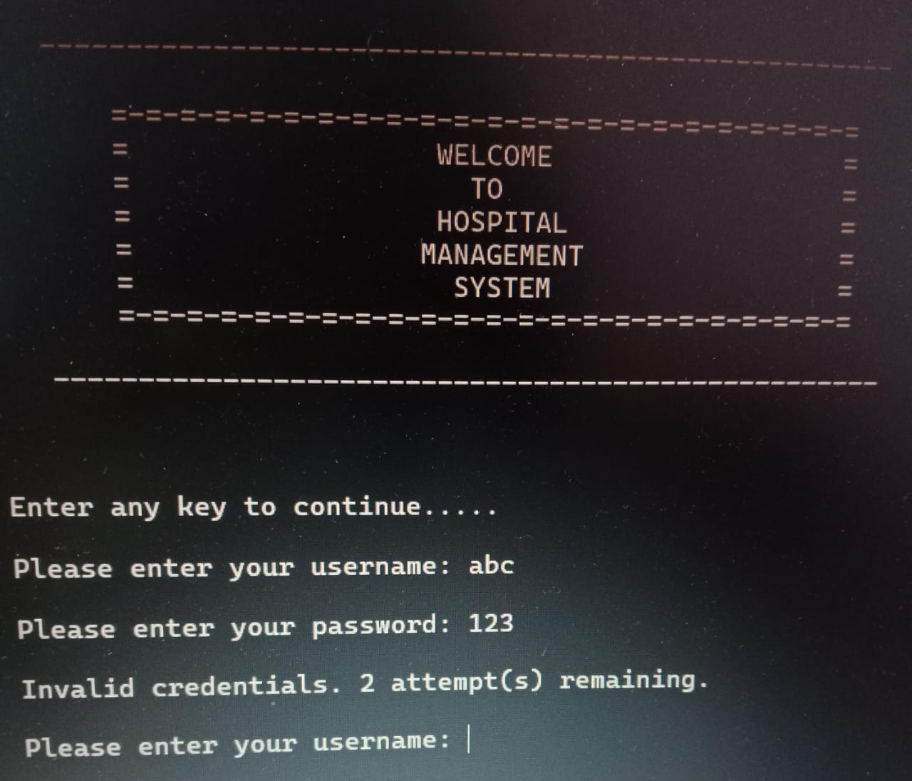

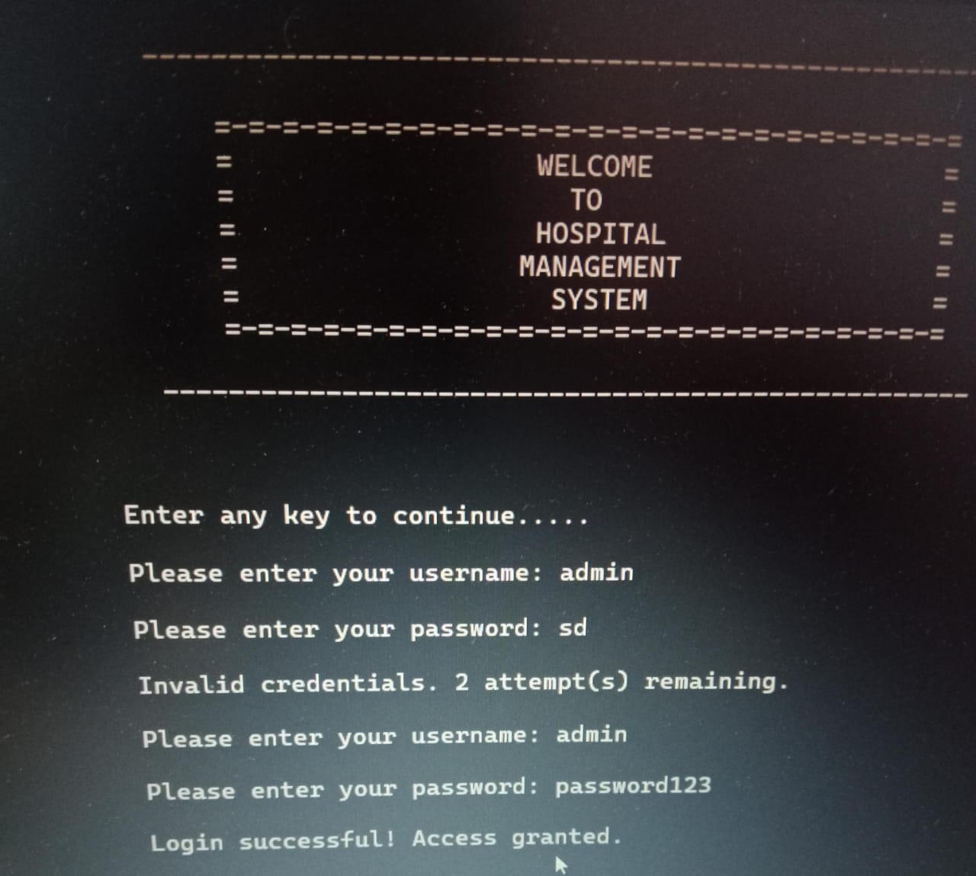

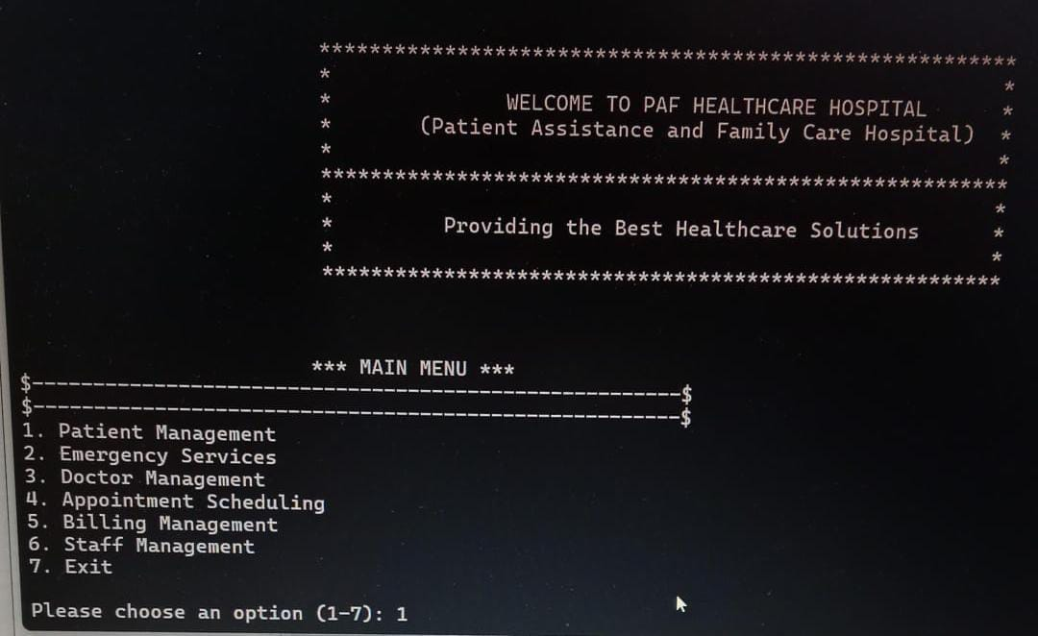

2.Patient Management:

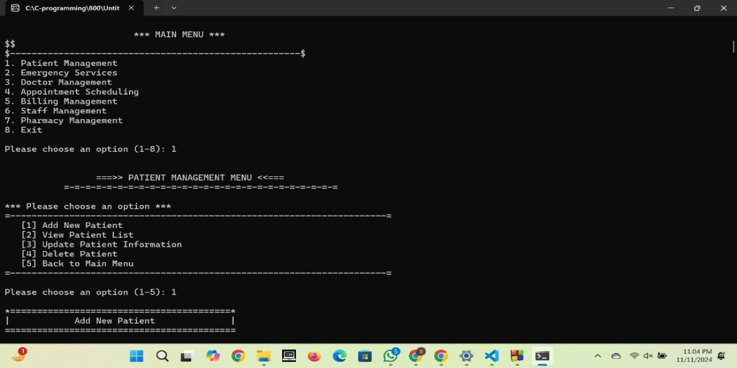

(i)Add New Parient

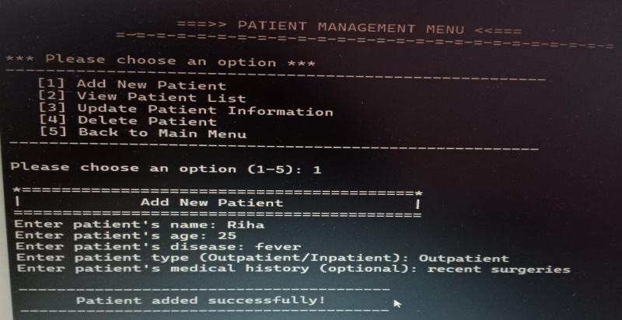

(ii)Veiw Patient List:

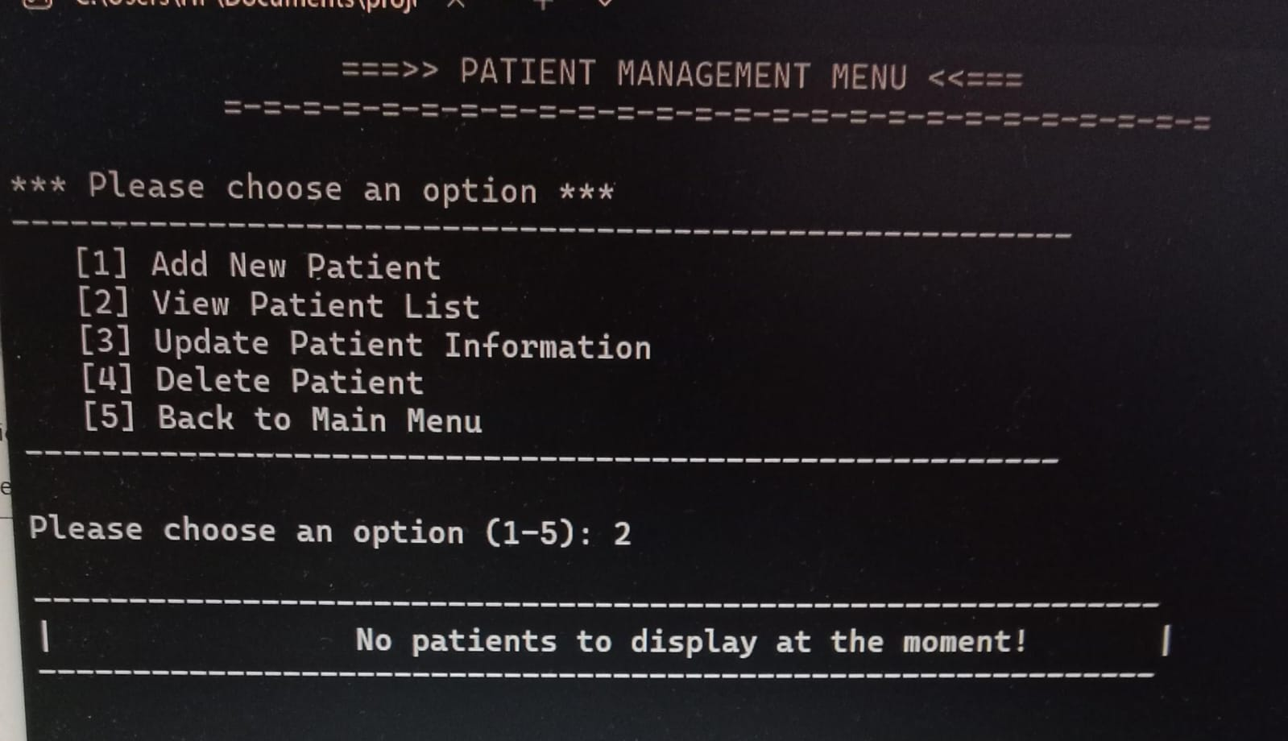

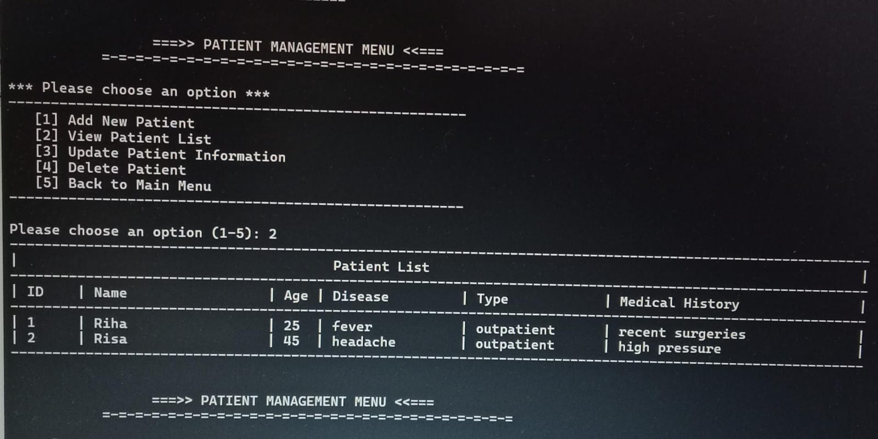 (iii)Update patient Information:

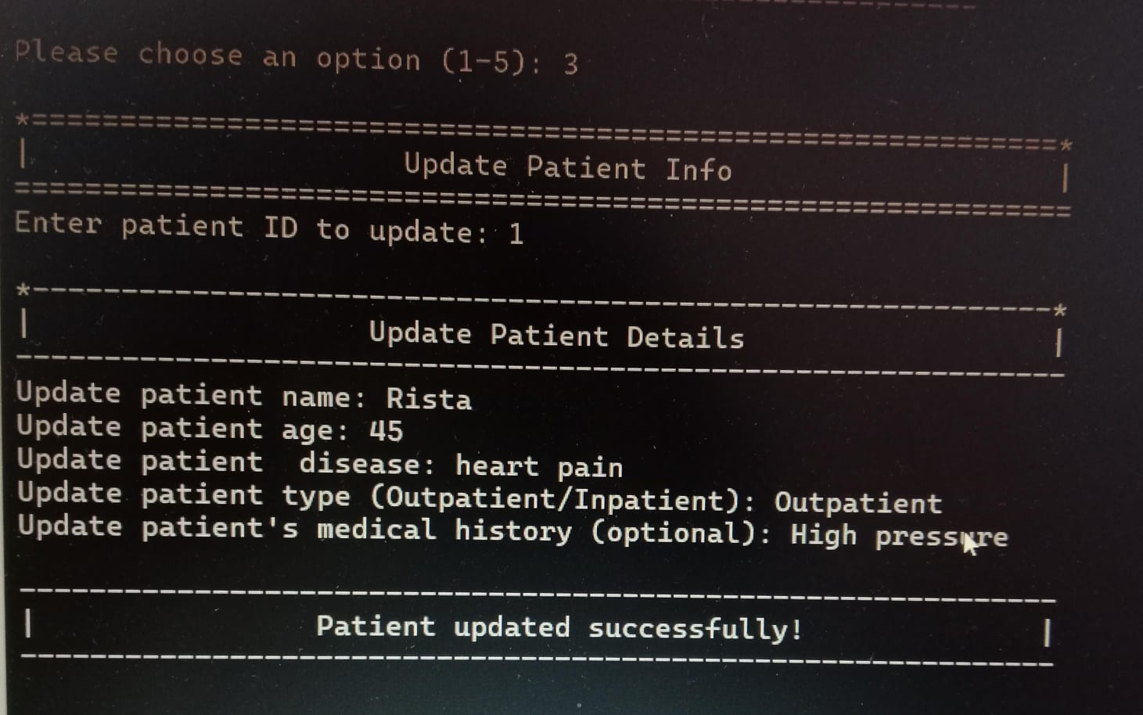(iv).Delete Patient:

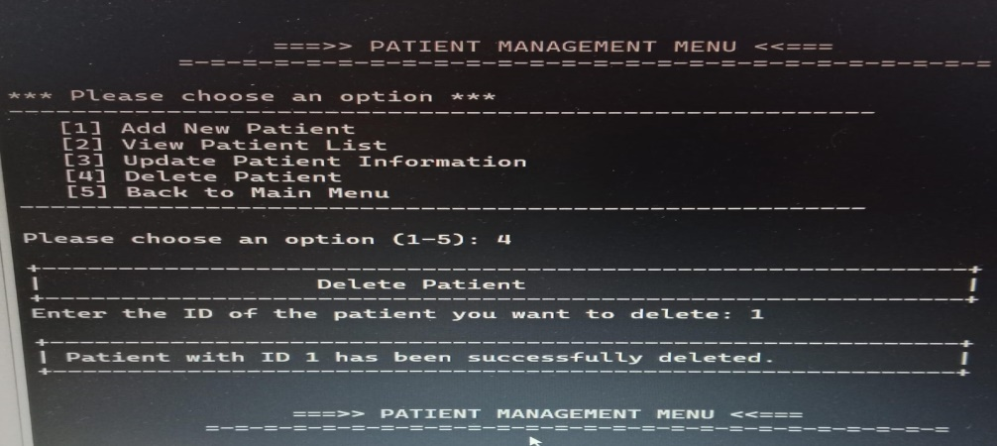

3.Emergency Services:

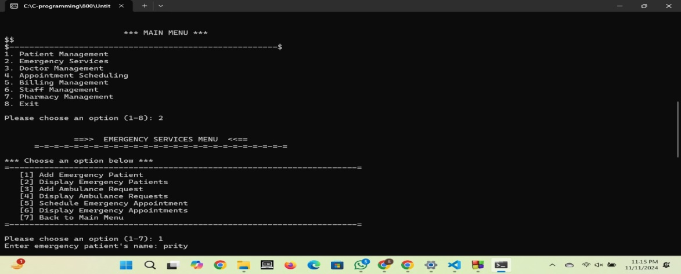

(i)Add Emergancy Patient:

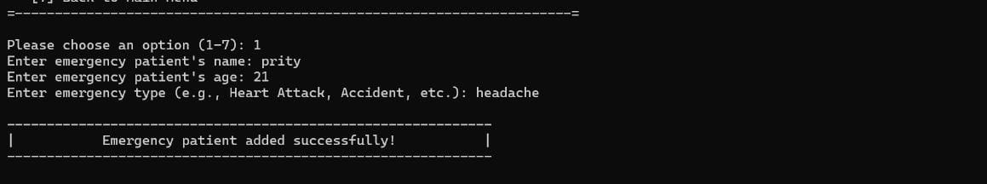

(ii)Display Emergency Patients:

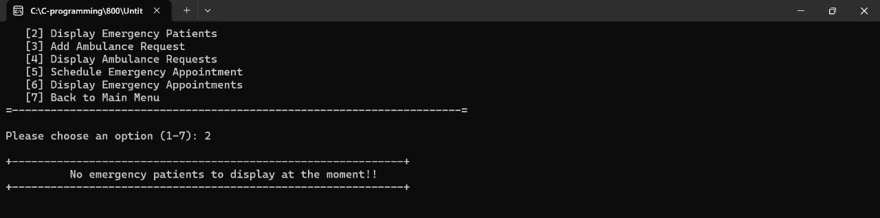

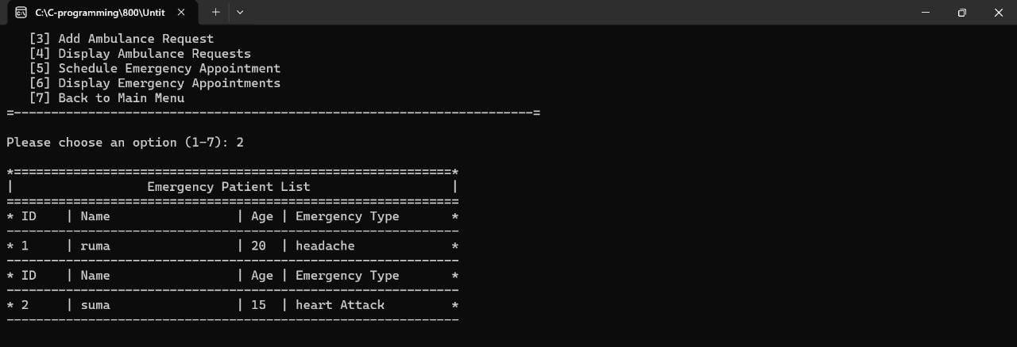

(iii)Add Ambulance Request:

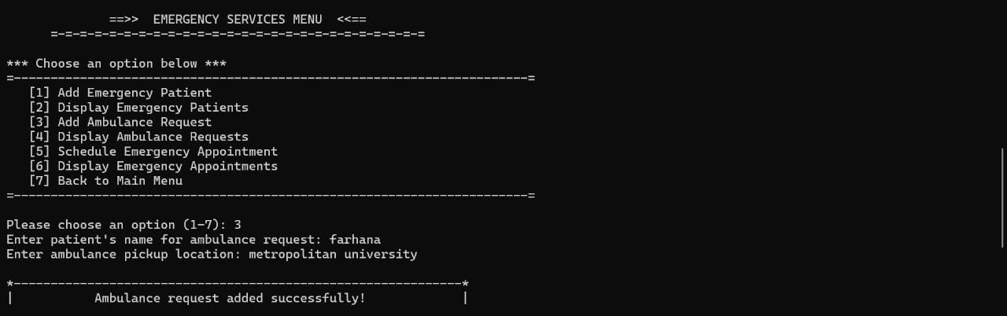

(iv)Display Ambulance Request:

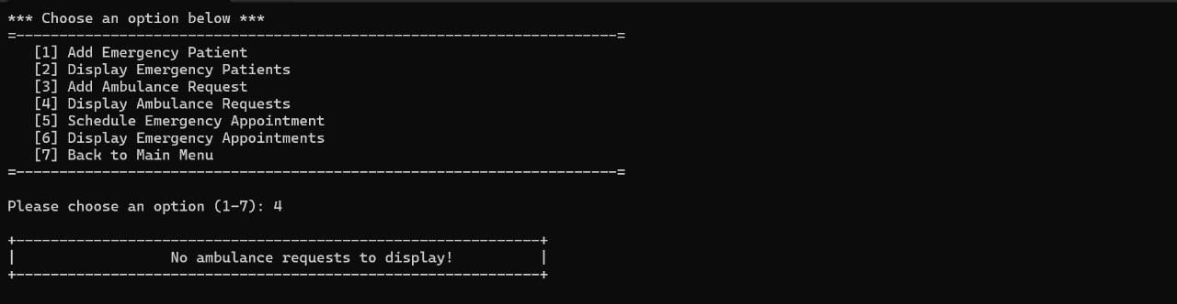

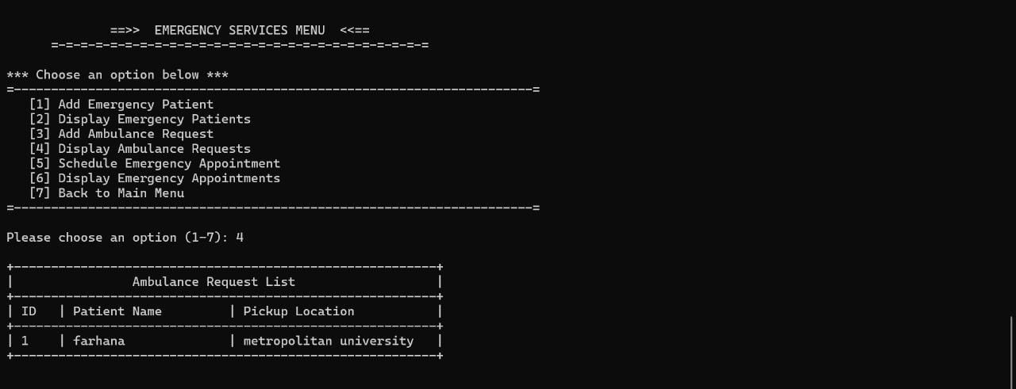

(v)Schedule Emergency Appointment:

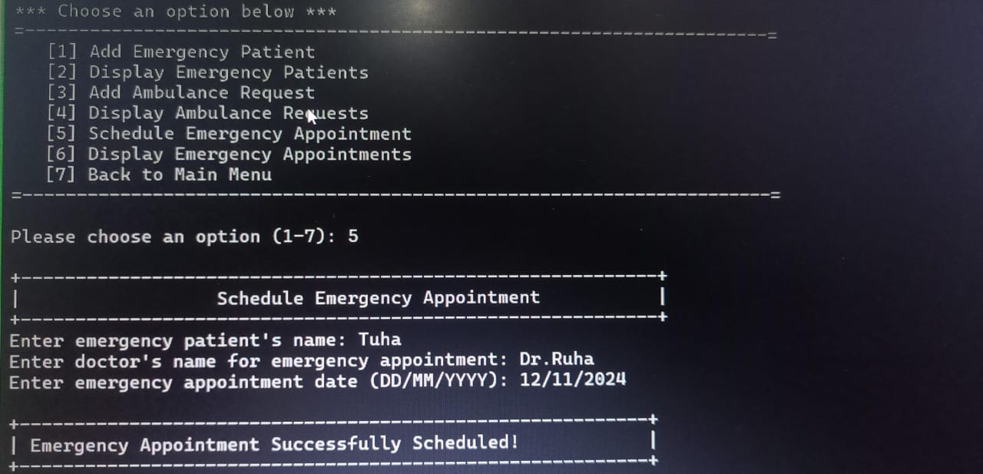

(vi)Display Emergency Appointments:

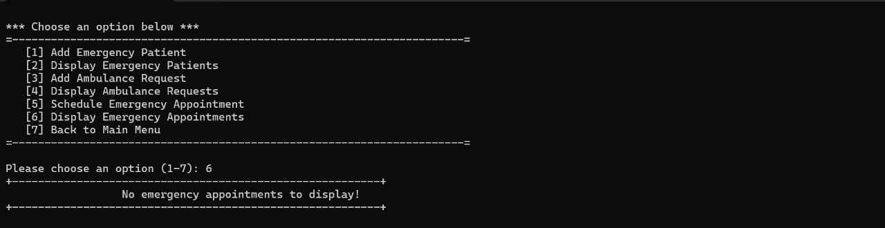

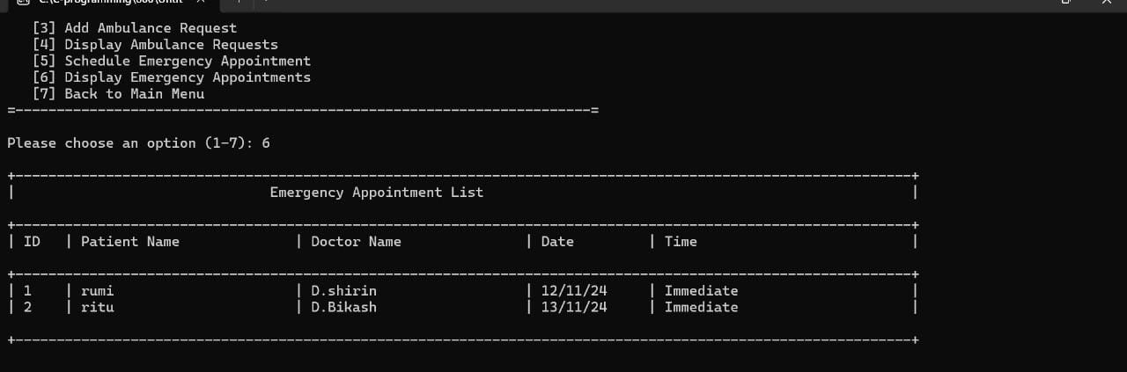

4.Doctor Management:

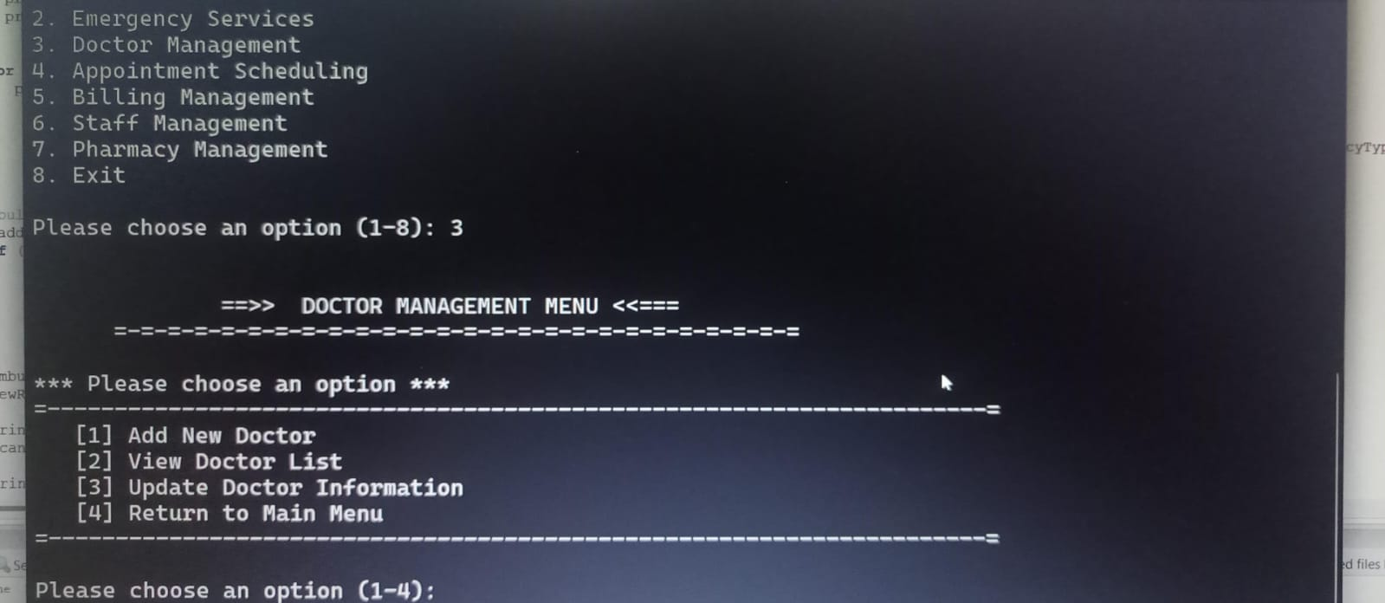

(i)Add New Doctor:

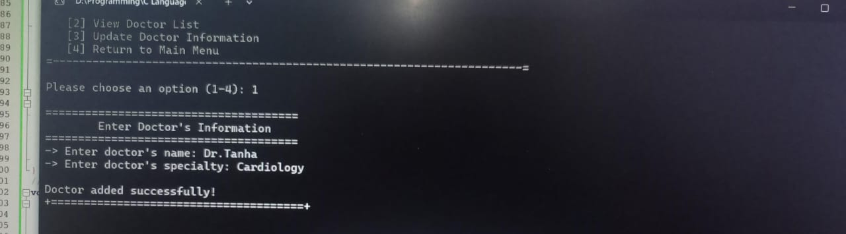

(ii)View Doctor List:

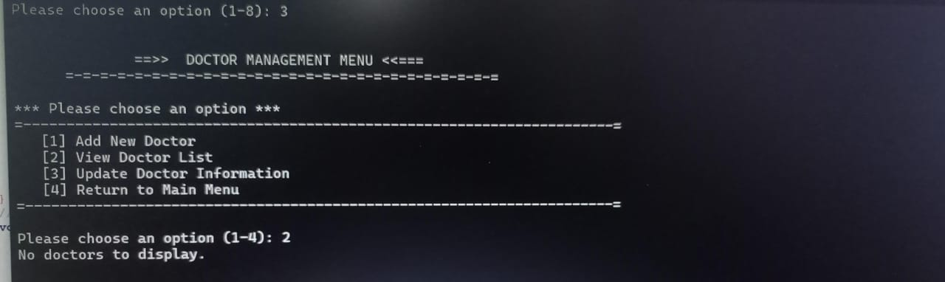

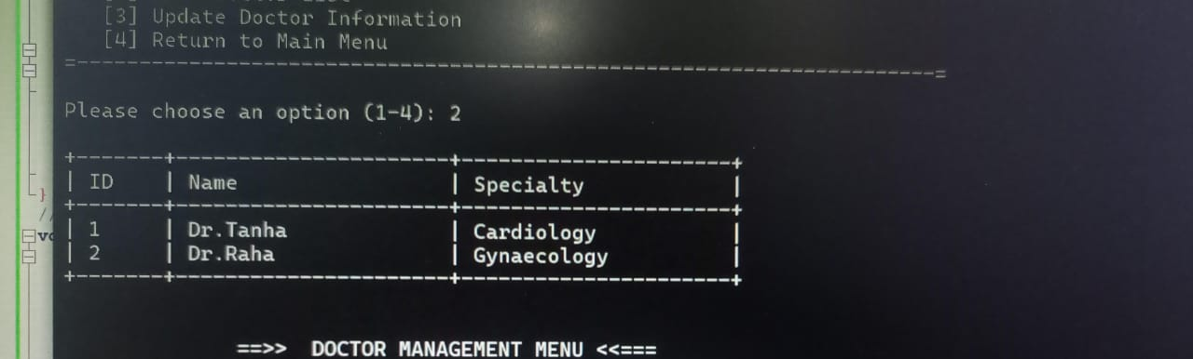

(iii)Update Doctor Information:

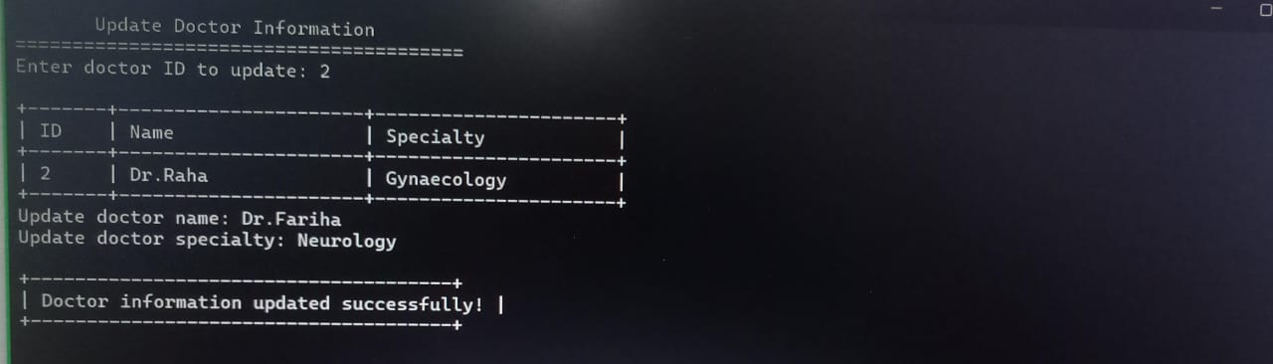

5.Appintment Scheduling:

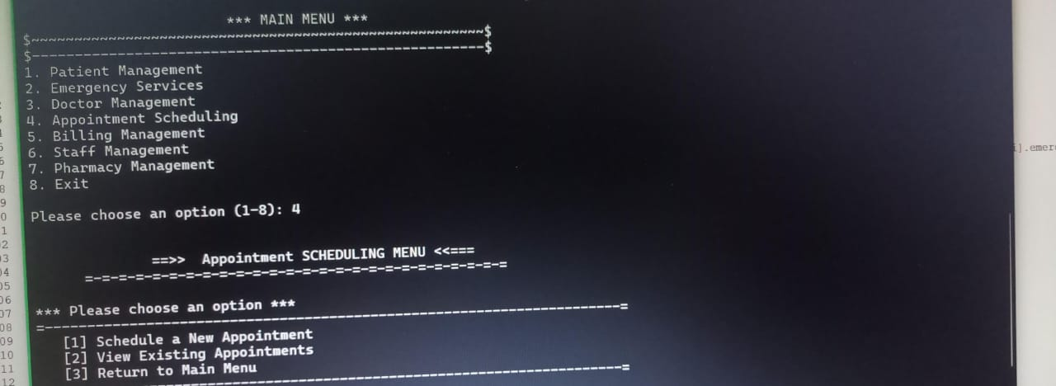

(i)Schedule a New Appointment:

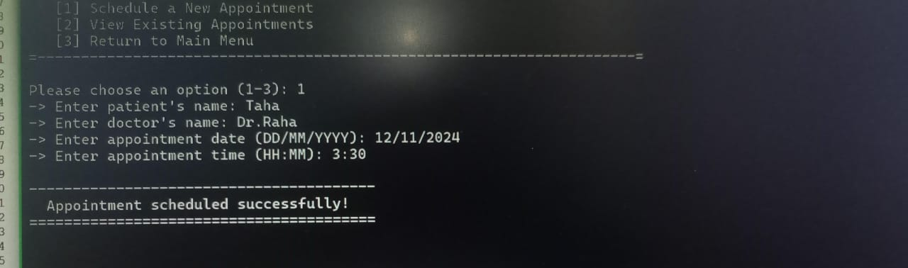

(ii)View Existing Appointment:

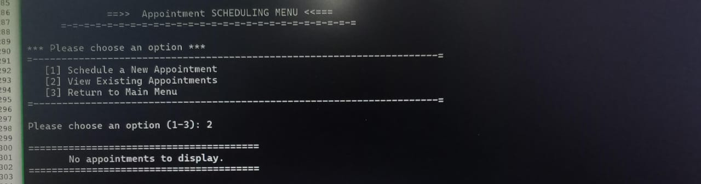

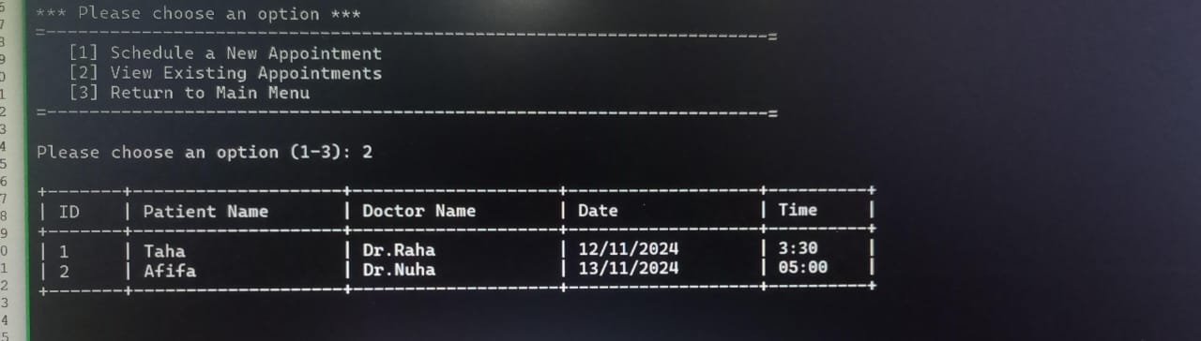

6.Billing Management:

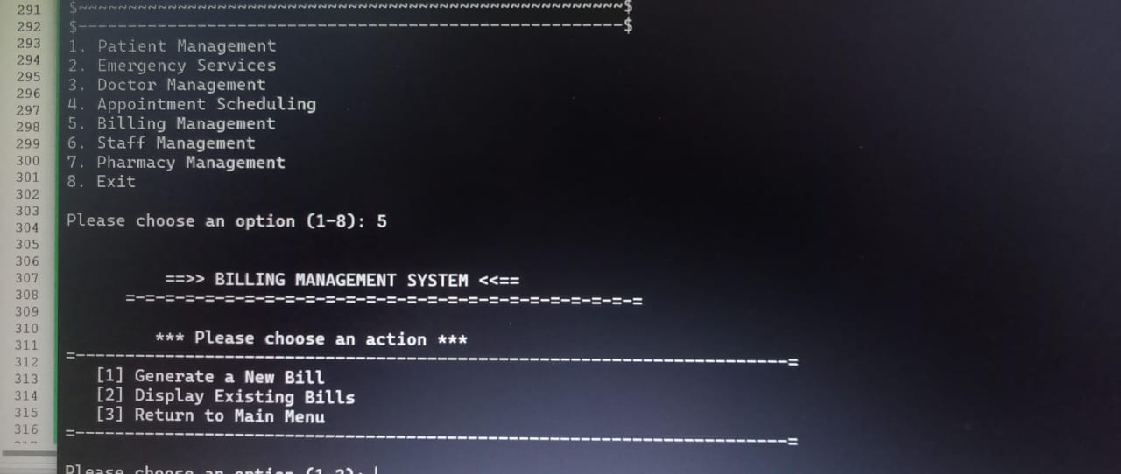

(i)Generate a New Bill:

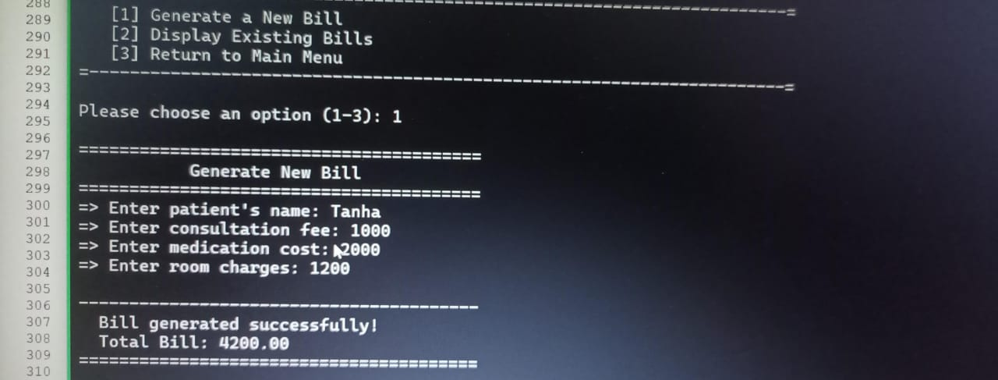

(ii)Display Existing Bills:

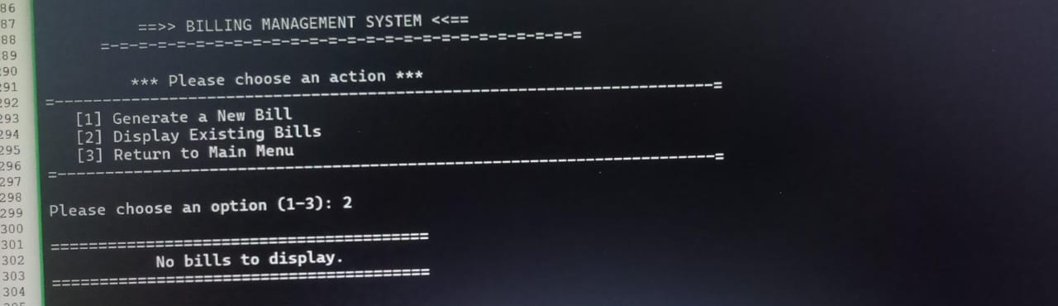

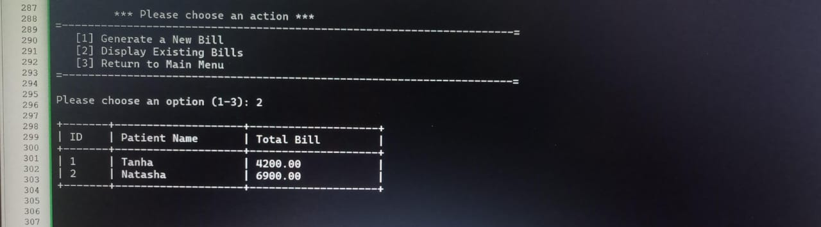

7.Staff Management:

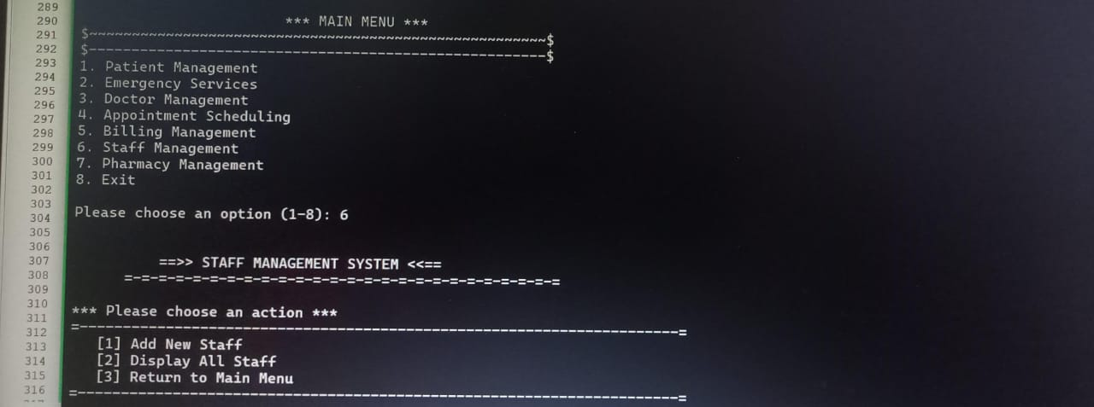

(i)Add New Staff:

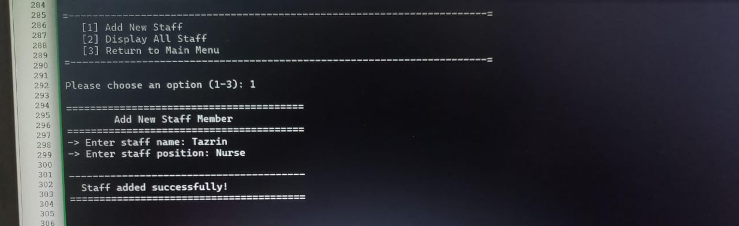

(ii)Display All Staff:

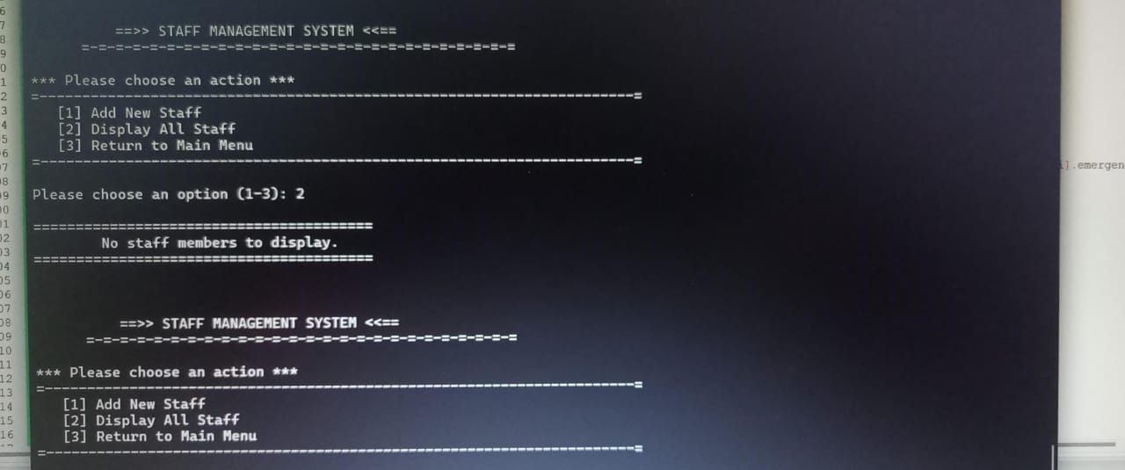

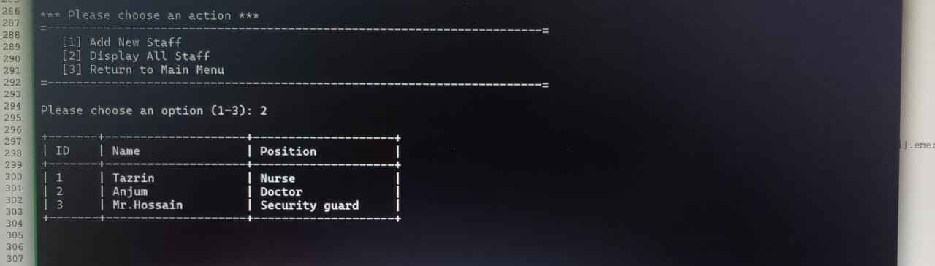

8.Pharmacy Management:

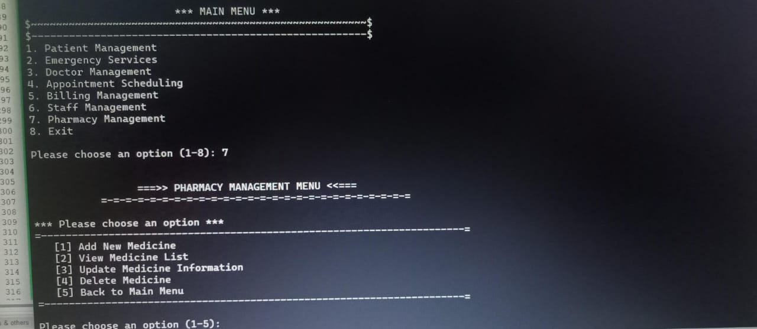

(i)Add New Medicine:

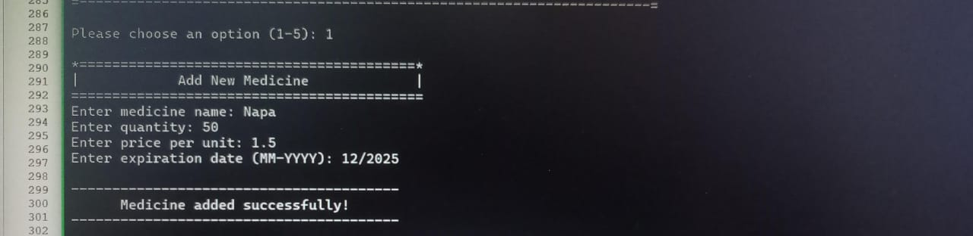

(ii)View Medicine List:

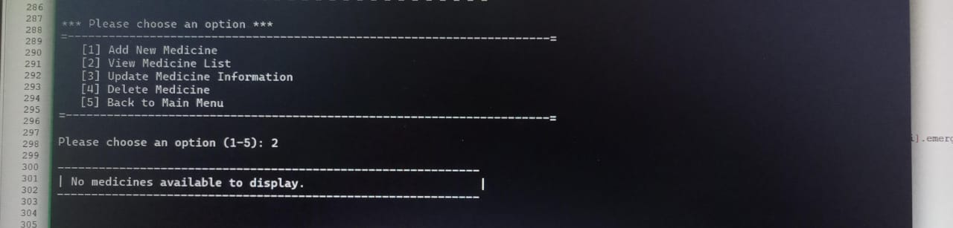

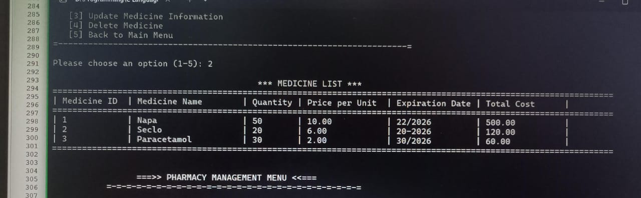

(iii)Update Medicine Information:

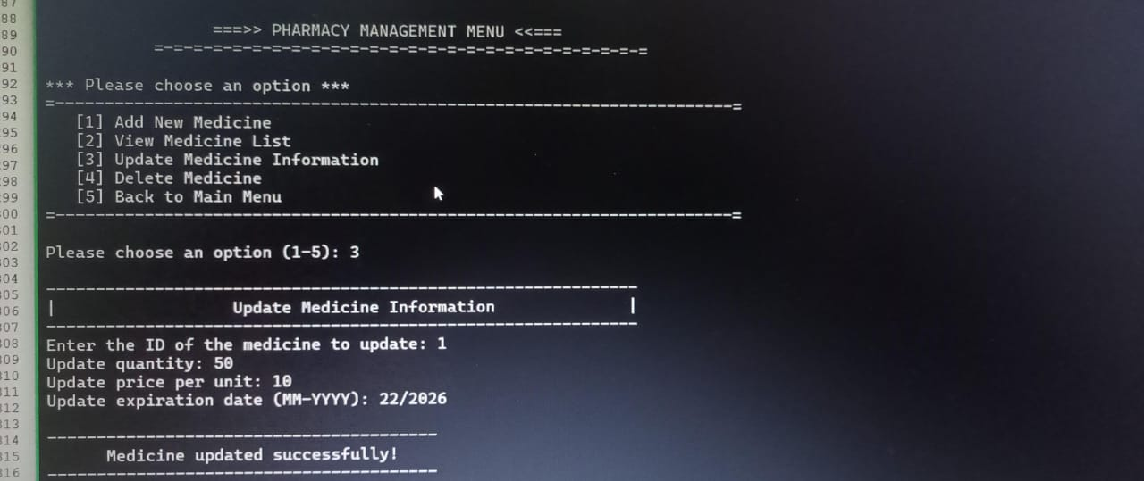

(iv)Delete Medicine:

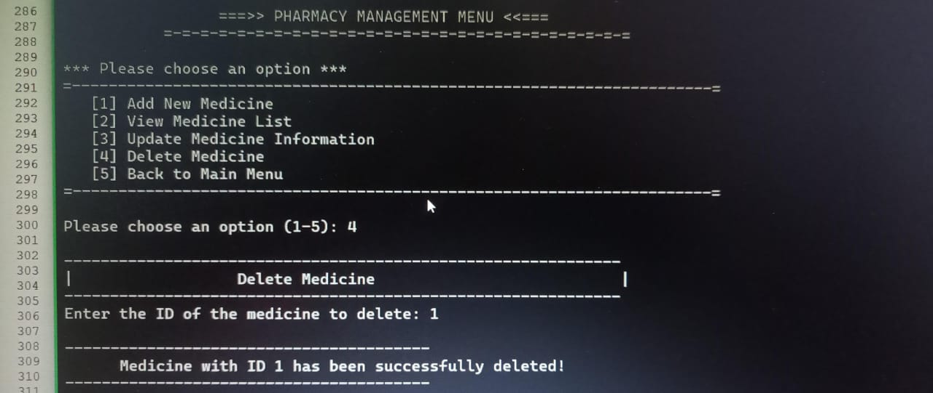

Limitations:

* Technical Limitations:

(i). Complexity: Implementing a comprehensive HMS can be complex, requiring significant technical expertise.

(ii).Interoperability Issues: Seamless integration with other healthcare systems can be challenging due to varying standards and data formats.

(iii).Scalability: As the hospital grows, the HMS may need to be scaled to accommodate increased workload and data volume.

(iv).Cyber security Threats: Hospitals are prime targets for cyber attacks, making data security a major concern.

* Human Factors:

(i).Resistance to Change: Healthcare professionals may be resistant to adopting new technology, especially if it disrupts their workflow.

(ii). User Error: Mistakes in data entry or system usage can lead to errors and inefficiencies.

(iii). Training and Support: Adequate training is essential for staff to effectively use the HMS, and ongoing support is needed to address issues and provide updates.

* Cost Considerations:

(i).Initial Investment: Implementing an HMS requires significant upfront costs, including hardware, software, and implementation services.

(ii).Ongoing Maintenance Costs: Regular maintenance, updates, and technical support are necessary to keep the system running smoothly.

(iii). Data Migration Costs: Migrating existing patient data to the new system can be time-consuming and expensive.

By understanding these limitations and carefully planning the implementation process, healthcare organizations can mitigate risks and maximize the benefits of an HMS.

Future scope:

1.For Patients:

* Improved Patient Experience:
* Easy Appointment Scheduling: Convenient online booking and reminders.
* Centralized Medical Records: Secure access to medical history and prescriptions.
* Faster Check-in and Check-out: Streamlined admission and discharge processes.
* Real-time Updates: Timely notifications about appointments, test results, and treatment plans.

2.For Doctors:

* Enhanced Efficiency:
* Digitalized Patient Records: Quick access to detailed patient information.
* Automated Scheduling: Optimized appointment management.
* Efficient Prescription Management: Electronic prescriptions and drug interaction alerts.
* Real-time Updates: Timely notifications about patient conditions and test results.

3.Improved Decision-Making:

* Data-Driven Insights: Data analytics to identify trends and improve patient care.
* Clinical Decision Support Systems: Evidence-based recommendations for diagnosis and treatment.

4.For Emergency Services:

* Faster Response Times:
* Real-time Patient Information: Access to critical patient data for rapid triage.
* Efficient Resource Allocation: Optimized bed management and staff scheduling.
* Streamlined Patient Registration: Quick patient intake and data entry.

5.For Billing and Finance:

* Accurate Billing:
* Automated Billing Processes: Reduced errors and faster billing cycles.
* Real-time Financial Reports: Improved financial visibility and decision-making.
* Insurance Claims Management: Simplified claims submission and tracking.

6.For Appointments:

* Efficient Scheduling:
* Automated Appointment Scheduling: Optimized time slots and reduced wait times.
* Real-time Appointment Management: Easy rescheduling and cancellation.
* Automated Reminders: Reduced missed appointments.

7.For Staff:

* Improved Workflow Efficiency:
* Automated Tasks: Streamlined administrative tasks, such as data entry and report generation.
* Centralized Communication: Enhanced collaboration among staff members.
* Reduced Paperwork: Digitalized records and electronic signatures.

8.For Pharmacy:

* Accurate Drug Dispensing:
* Real-time Inventory Management: Optimized stock levels and reduced drug shortages.
* Automated Prescription Processing: Faster prescription filling and reduced errors.
* Drug Interaction Alerts: Improved patient safety.

Conclusion:

A Hospital Management System (HMS) is a comprehensive solution that streamlines various aspects of hospital operations. By integrating modules for patient management, emergency services, doctor management, appointment scheduling, billing, staff management, and pharmacy management, HMS optimizes workflows, reduces errors, and enhances patient care. It empowers healthcare providers to deliver timely and accurate care, improves operational efficiency, facilitates data-driven decision making, and improves staff productivity. By adopting HMS, hospitals can achieve greater efficiency, accuracy, and patient satisfaction, ultimately leading to improved patient outcomes.

1. <https://sg.docworkspace.com/d/sIACHhaKPAqvvvLkG?sa=601.1123&ps=1&fn=Hospital%20Managment%20Project%20SE-converted.pdf>
2. <https://search.app?link=https%3A%2F%2Fwww.researchgate.net%2Fpublication%2F380505845_Hospital_Management_System_Project_Report&utm_campaign=aga&utm_source=agsadl2%2Csh%2Fx%2Fgs%2Fm2%2F4>
3. <https://search.app?link=https%3A%2F%2Fwww.geeksforgeeks.org%2Fc-program-for-hospital-management-system%2F&utm_campaign=aga&utm_source=agsadl2%2Csh%2Fx%2Fgs%2Fm2%2F4>